



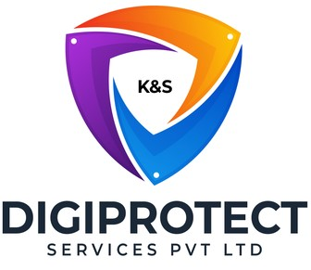

INITIAL
ASSESSMENT
REPORT

DATE: 13th June 2024
Internal Audit,
Field Audit &
Anti-Fraud

VERSION: 1.2

Document History
Document version | Remarks | Submitted  By | Submission  Date | Approved BY | Approval  Date
1.0 | First Draft | k&S Digiprotect | 28th May 2024
1.1 | Second Draft | k&S Digiprotect | 6th June 2024
1.2 | Third Draft | k&S Digiprotect | 13th June 2024

Table of Contents
Introduction 4
Objectives 4
General Information 5
SPOC Information 5
Department Hierarchy* 6
Key Processes 7
Data Flow Diagram (DFD) 11
Data Mapping and Inventory 12
Recommendations 13
Conclusion 13
Appendices 13
Appendix A 13

Introduction
India Shelter Finance Corporation Limited (ISFC) relies on its Internal Audit Department to ensure that the organization operates in compliance with regulatory standards and internal policies. The department is divided into two key functions: Internal Audit, Field Audit & Anti-Fraud. This team of experienced professionals conducts thorough audits across various departments and branches, employing a structured approach to audit planning and execution.
This report encapsulates critical insights for As-Is study, derived from the initial interview conducted with the Internal Audit Department of India Shelter Finance Corporation Limited (ISFC) for the implementation of ISO/IEC 27001:2022 and compliance with the Digital Personal Data Protection Act (DPDPA).
The overarching objectives of this interview were dual fold: first, to gain an understanding of the departmental structure, and second, to delve into the core operational processes of the Internal Audit Department. Additionally, the interview aimed to assess the existing information security practices, focusing on evaluating adherence to DPDPA requirements and the readiness for ISO/IEC 27001:2022 implementation.
By delving into the details of the department's organizational setup, operational workflows, and data handling procedures, this report aims to identify both the strengths and areas of improvement in information security management and DPDPA compliance within the department.

Objectives
- Understand the departmental hierarchy and reporting structure
- Learn the existing processes of ISFC’s Internal Audit, Field Audit & Anti-Fraud Department
- Mapping of existing processes with documented processes
- Offer recommendations to optimize the existing processes

General Information
Organization Name | India Shelter Finance Corporation Limited
Department Name | Internal Audit  Field Audit & Anti-Fraud Department
Date of the Assessment | Internal Audit – 14th March 2024  Field Audit & Anti-Fraud Department – 25th April 2024
Location | 3rd Floor, 6th Floor, India Shelter HQ, Gurugram
Meeting Duration | Internal Audit – 1 hr  Field Audit & Anti-Fraud Department – 1 hr
Attendees (ISFC) | Iqbal Singh, Shivam Jain, Kavit Rajput, Dheeraj Yadav, Sunil Kumar Sharma
Attendees (Digiprotect) | Lalit Mohan Joshi, Sushil Menon, Manav Mahajan, Aman Varma, Adhita Razdan

SPOC Information
Project SPOC: Dheeraj Yadav
Contact Information:
Email ID: dheeraj.yadav@indiashelter.in

Project Coordinator: Sunil Kumar Sharma
Contact Information:
Email ID: sunil.sharma2@indiashelter.in

Department SPOCs:
- Internal Audit – Shivam Jain
- Field Audit & Anti-Fraud Department – Kavit Rajput
Contact Information:
Email IDs:
- Internal Audit: shivam.jain@indiashelter.in
- Field Audit & Anti-Fraud Department: kavit.rajput@indiashelter.in

Department Hierarchy*

* As informed during the meeting

Key Processes
S. No | Key Activities | Observations and Asks | Remarks
 | Internal Audit (IA) Operations  - Audit Charter Planning  - Identification of critical departments and processes is done based on past audits, past experiences, and management requirements.  - Critical departments identified for internal audit are operations, credit, finance, and sales.  - An annual audit charter is prepared by the IA team and approved by the Audit Committee.  - The Audit Committee comprises of the Managing Director (MD), Chief Financial Officer (CFO), Chief Risk Officer (CRO), Head of Internal Audit, and Company Secretary (CS).  - Audits are conducted according to NHB, RBI, and IT audit guidelines, ensuring compliance with regulatory standards.  - Execution of Audits  - Process and Department audits are carried out by Assistant Managers and AVP audits.  - Senior Executives carry out loan audits and disbursement audits using a checklist-based approach, and observations are raised.  - Call centres are audited on access controls, call recordings, CDR (Call Detail Record) reviews, and KYC details of customers.  - Sampling methodology is used where samples are collected based on the population size and auditor judgement; these samples are maintained on Excel.  - The IA team uses various tools and technologies such as Excel, and OneDrive for maintaining audit data and records.  - Audit Findings and Closure  - Reporting and follow-up of audit findings are sent to process owners and reporting managers, and closed when supporting documents from respective departments are received.  - Sharing of audit findings is done via email.  - Internal audit reports are sent to the board quarterly.  - All data (data received for audit, audit findings) is retained for a time period based on the internal ISFC Policy(Policy for Preservation of Documents). | NA | - ISFC to explain process audit of Sales department.
 | Field Audit Operations  - Audit Charter  - Audit Charter is prepared at the beginning of every financial year.  - All branches are audited annually, once they have been operational for six months.  - Branch Audits  - Branch audit process includes two days:  Day 1: Compliance and Basic Hygiene Checks  - Field Audit team arrives at the branch location before it opens to conduct pre-visit checks, including verifying geotags.  - Ensure NHB and RBI notices are current and displayed correctly.  - Evaluate branch cleanliness and organization.  - Verify proper storage of documents and registers.  Day 2: Customer and Vendor Visits  - Customer visits include location checks, KYC checks, and verification of loan usage. Physical verification is done to ensure that location of property is same and documented and loans are used for intended purpose.  - Vendor visits are conducted by the Audit team which include checks on undue pressure from branches and payout information. Payout information includes details of financial transactions to vendors.  - During vendor visits, the field audit team gathers market inputs from competitors. This involves understanding the competitive landscape, identifying market trends, and assessing how the branch's practices compare to industry standards  - Findings regarding document management are addressed on-site during branch audits.  - Audit Trail and Reporting  - Audit trail is maintained on OneDrive and emails, with no defined retention period.  - Findings from field audits that are not closed on the same day are resolved after receiving confirmation mail with photographs from respective branches.  - Quarterly reports with a scoring model for branches are shared with the board. | - No defined retention period for audit trails. | - ISFC to share documentation on scoring models for branches.
 | Anti-Fraud Activities  - Anti-Fraud Activities  - The Anti-Fraud team, led by Kavit Rajput, investigates customer complaints.  - Anti-fraud investigations involve understanding queries, collecting proofs, and resolving issues in a written or verbal manner.  - Query Verification  - Customer verification involves verifying customer identity.  - Query verification includes understanding customer issues, gathering necessary proofs, and providing resolutions. | - ISFC to confirm Vendor Visit process.  - ISFC to explain what all data is captured in log sheets when a complaint is received, and who all have access to the log sheet.  - ISFC to explain how customer verification is done during Query Verification process. | NA

Data Flow Diagram (DFD)
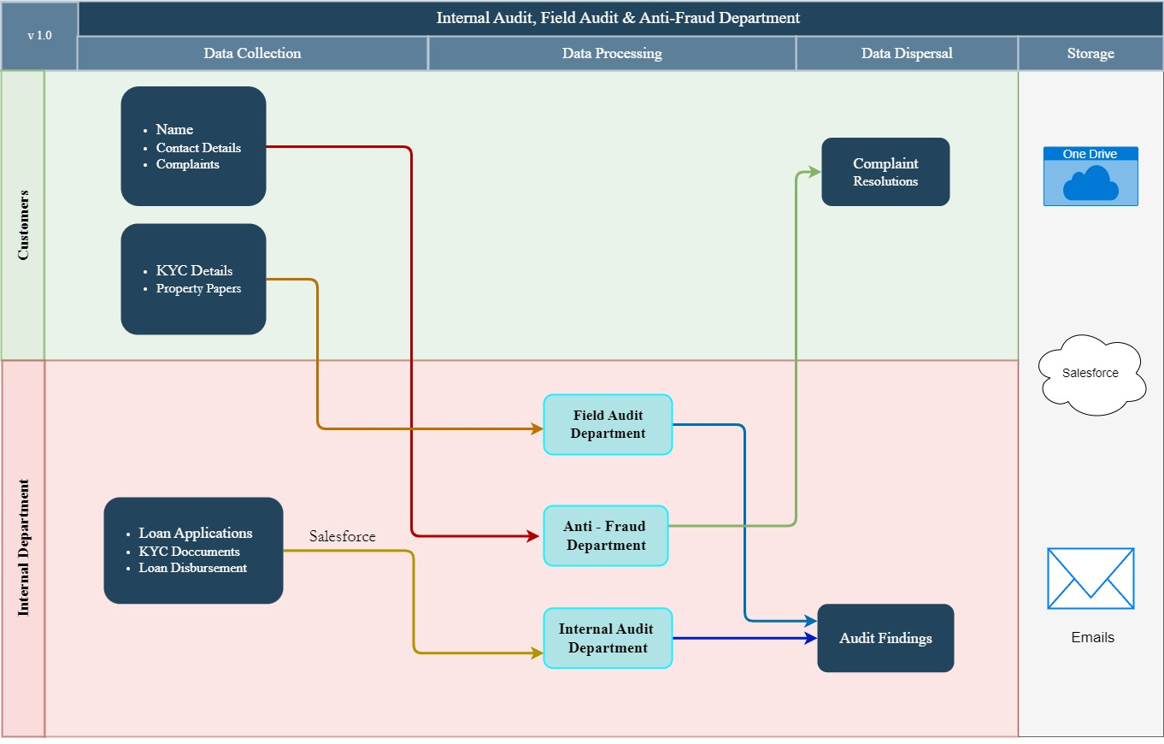

Data Mapping and Inventory
S. No | Data Category | Description | Purpose | Data Owner | Storage Location | Data Classification* | Retention Period | Legal Basis
1 | CDR (Call Detail Record) | Records for call centre monitoring and performance assessment. | Audit | Customer Care | Salesforce | PII/Sensitive Data | 8 years | Consent/ Internal Policy
2 | KYC Documents | Customer identity verification documents | Audit | Internal Audit | Salesforce | PII/Sensitive Data | 8 years | Consent/ Internal Policy
3 | Loan Documents | Paperwork for loan disbursements and usage verification audits. | Audit | Internal Audit | Salesforce OneDrive Email | PII/Sensitive Data | 8 years | Legitimate Interest/ Internal Policy
4 | Customer Feedback | Input obtained from customers during field visits | Audit | Field Audit | OneDrive Email | PII/ Sensitive | 8 years | Consent/ Internal Policy
5 | Vendor Information | Details on vendor audits, payout information, and market insights. | Audit | Field Audit | Salesforce OneDrive Email | Non-PII/  Private | Not Applicable | NA
6 | Financial Records | Records used for financial transactions and auditing purposes. | Audit | Internal Audit | Salesforce OneDrive Email | Non- PII/ Confidential | Permanent | Legitimate Interest
*Refer Appendix A

Recommendations
- Ensure that all evidence maintained on Excel is encrypted to protect confidential information from unauthorized access.
- Include data privacy-related audits in the annual audit charter for both internal and field audits to ensure compliance with data protection regulations.
- Establish a clear policy to avoid retaining legacy data indefinitely. Retain audit data only for the necessary period as per regulatory requirements.

Conclusion
The Internal Audit Department of India Shelter Finance Corporation Limited (ISFC) plays a critical role in maintaining the organization's adherence to regulatory standards and internal policies. Through its comprehensive approach to audit planning and execution, the department ensures that all critical areas, including operations, credit, finance, and sales, are thoroughly examined. The rigorous audit processes, which encompass both internal and field audits, are designed to identify any discrepancies and areas for improvement. The detailed and systematic approach of the department ensures that audit findings are promptly addressed.

Appendices

Appendix A
Data Classification | Definition
Sensitive Data | Information that, if disclosed, altered, or destroyed without authorization, could cause significant harm to an individual, organization, or entity. This often includes financial records, medical information, and PII.
Restricted Data | Highly sensitive data tightly controlled due to legal, regulatory, or contractual requirements. Access is limited to authorized personnel, and any unauthorized disclosure may result in severe consequences.
Private Data | Information considered confidential and intended solely for specific individuals or groups within an organization. It requires protection from unauthorized access to maintain privacy and uphold confidentiality agreements.
Confidential Data | Privileged or proprietary information of an organization requiring protection from unauthorized access, disclosure, or alteration.
Public Data | Information that is freely available and accessible to the general public without restrictions or limitations. It does not contain sensitive or confidential information and can be openly accessed and used for various purposes such as research, analysis, and public interest initiatives.
PII (Personally Identifiable Information) | Data that can identify, contact, or locate an individual, either alone or in combination with other information. For example - names, addresses, official identifiers (Aadhar, Pan, DL, biometrics, etc).
Non-PII | Data that, while not personally identifiable, however may still require protection due to its sensitivity or confidentiality. This may include corporate financial information, proprietary research data, or internal communications.

-------------------------End of report for Internal Audit, Field Audit & Anti-Fraud ---------------------------

